CS 575

Project #2

Numeric Integration with OpenMP Reduction

Xuming Wu

wuxum@oregonstate.edu

Code was run on the flip server. Got results as:

From observation, regardless of the number of threads, the curves of the performance all appear increased and then maintain stable. I think the curves appear increased because the workload of each thread is not saturated, and then they maintain stable since the workload is saturated.

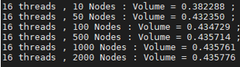

Run the program with NUMT = 16, we got results as above. The number of threads did not affect the total volume, but the number of nodes did, which is: as the number of nodes grows, the volume is closed to 0.4358. Thus, we can estimate that the actual volume is 0.4358.

Consider # of nodes = 2000, the speed-up and the Parallel Fraction are:

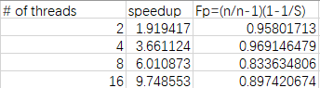

Consider Fp = 0.89742,